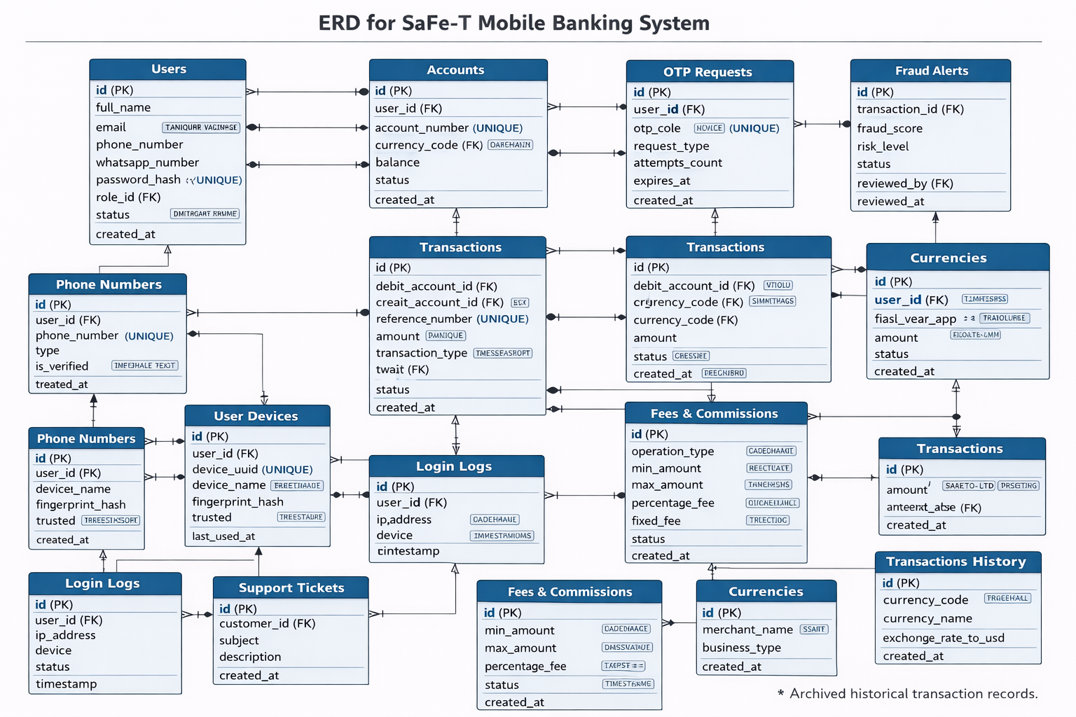

1️⃣ Users
Purpose: Stores all users of the system including Admins, Customers, Tellers, Risk Officers, Customer Service staff, and Merchants.
Fields:
- id (INT, PK, auto-increment): Unique user identifier.
- full_name (VARCHAR): User’s full name.
- email (VARCHAR, UNIQUE): User email for login/communication.
- phone_number (VARCHAR): Main contact number.
- whatsapp_number (VARCHAR): Number for OTP via WhatsApp.
- password_hash (VARCHAR): Hashed password for authentication.
- role_id (INT, FK → Roles.id): Role assigned to user.
- status (ENUM: Active, Inactive): Current account status.
- created_at (DATETIME): Account creation timestamp.
- kyc_status (ENUM: Pending, Verified, Rejected): Tracks Know-Your-Customer verification.
Relationships:
- Many Users → One Role
- One User → Many Accounts
- One User → Many OTPRequests
- One User → Many LoginLogs
- One User → Many SupportTickets

2️⃣ Roles
Purpose: Defines different types of users and their permissions.
Fields:
- id (INT, PK): Role ID.
- role_name (VARCHAR): Name of the role (Admin, Customer, Teller, etc.)
Relationships:
- One Role → Many Users

3️⃣ Accounts
Purpose: Represents a bank account for each user, including balance and currency.
Fields:
- id (INT, PK): Unique account identifier.
- user_id (INT, FK → Users.id): Owner of the account.
- account_number (VARCHAR, UNIQUE): Unique account number.
- currency_code (VARCHAR, FK → Currencies.code): Currency of the account.
- balance (DECIMAL): Current account balance.
- status (ENUM: Active, Blocked): Account operational state.
- created_at (DATETIME): Account creation timestamp.
Relationships:
- One User → Many Accounts
- One Account → Many Transactions (as debit or credit)

4️⃣ Transactions (Ledger Approach)
Purpose: Tracks all financial operations using double-entry (Debit & Credit) to ensure balance integrity.
Fields:
- id (BIGINT, PK): Unique transaction identifier.
- debit_account_id (INT, FK → Accounts.id): Account money is withdrawn from.
- credit_account_id (INT, FK → Accounts.id): Account money is deposited to.
- reference_number (VARCHAR, UNIQUE): Unique transaction reference for tracking.
- amount (DECIMAL): Transaction amount.
- transaction_type (ENUM: Transfer, Deposit, Withdrawal): Type of transaction.
- currency_code (VARCHAR, FK → Currencies.code): Currency of transaction.
- status (ENUM: Pending, Completed, Failed): Transaction state.
- performed_by (INT, FK → Users.id): User who executed the transaction.
- created_at (DATETIME): Timestamp of transaction creation.
Relationships:
- Transactions link Accounts (Debit & Credit)
- Transactions may generate FraudAlerts

5️⃣ OTPRequests
Purpose: Manages OTP verification requests securely.
Fields:
- id (INT, PK): Unique OTP request ID.
- user_id (INT, FK → Users.id): Linked user.
- otp_code (VARCHAR, UNIQUE): OTP code.
- request_type (ENUM: Login, Transfer, PasswordChange): Purpose of the OTP.
- attempts_count (INT, default 0): Number of failed attempts.
- expires_at (DATETIME): Expiration of OTP.
- status (ENUM: Pending, Verified, Expired): Current state of OTP.
- created_at (DATETIME): Timestamp of request creation.
Relationships:
- Linked to one User

6️⃣ FraudAlerts
Purpose: Detects and tracks suspicious transactions for review.
Fields:
- id (INT, PK): Unique alert ID.
- transaction_id (BIGINT, FK → Transactions.id): Related transaction.
- fraud_score (DECIMAL): Likelihood of fraud (0–100).
- risk_level (ENUM: Low, Medium, High): Categorized risk.
- status (ENUM: Pending, Reviewed, Blocked): Alert status.
- reviewed_by (INT, FK → Users.id): Risk officer who reviewed it.
- reviewed_at (DATETIME): Timestamp of review.
Relationships:
- Many Alerts → One Transaction
- Many Alerts → One User (Risk Officer)

7️⃣ LoginLogs
Purpose: Keeps record of all login attempts for security and auditing.
Fields:
- id (BIGINT, PK): Log ID.
- user_id (INT, FK → Users.id): User attempting login.
- ip_address (VARCHAR): IP address used.
- device (VARCHAR): Device info.
- status (ENUM: Success, Failed): Outcome of attempt.
- timestamp (DATETIME): Date and time of login.

8️⃣ SupportTickets
Purpose: Tracks customer support requests.
Fields:
- id (INT, PK): Ticket ID.
- customer_id (INT, FK → Users.id): Customer raising the ticket.
- subject (VARCHAR): Ticket title.
- description (TEXT): Detailed issue description.
- status (ENUM: Open, Pending, Closed): Ticket state.
- handled_by (INT, FK → Users.id): Staff assigned.
- created_at (DATETIME): Timestamp of ticket creation.

9️⃣ MerchantProfiles
Purpose: Stores information about business users/merchants.
Fields:
- id (INT, PK): Profile ID.
- user_id (INT, FK → Users.id): Linked user account.
- business_name (VARCHAR): Merchant business name.
- business_type (VARCHAR): Type of business.
- created_at (DATETIME): Profile creation date.
Relationships:
- One User → One MerchantProfile
- One MerchantProfile → Many QRPayments

🔟 QRPayments
Purpose: Handles payments via QR codes for merchants.
Fields:
- id (BIGINT, PK): QR payment ID.
- merchant_account (INT, FK → Accounts.id): Merchant account receiving payment.
- qr_code (VARCHAR): Generated QR code.
- amount (DECIMAL): Payment amount.
- status (ENUM: Pending, Completed, Failed): Payment status.
- created_at (DATETIME): Timestamp of payment.

1️⃣1️⃣ FeeSchedules
Purpose: Stores flexible fee and commission rules for operations.
Fields:
- id (INT, PK): Fee schedule ID.
- operation_type (VARCHAR): Type of operation (transfer, bill payment).
- min_amount (DECIMAL): Minimum transaction amount for fee.
- max_amount (DECIMAL): Maximum transaction amount for fee.
- percentage_fee (DECIMAL): Percentage-based fee.
- fixed_fee (DECIMAL): Fixed fee amount.
- status (ENUM: Active, Inactive): Schedule state.
- created_at (DATETIME): Timestamp of schedule creation.

1️⃣2️⃣ UserDevices
Purpose: Tracks trusted devices for users to enforce device binding and step-up authentication.
Fields:
- id (INT, PK): Device ID.
- user_id (INT, FK → Users.id): Linked user.
- device_uuid (VARCHAR, UNIQUE): Unique device identifier.
- device_name (VARCHAR): Human-readable device name.
- fingerprint_hash (VARCHAR): Optional biometric hash.
- trusted (BOOLEAN, default false): Trusted device flag.
- last_used_at (DATETIME): Last login timestamp from device.

1️⃣3️⃣ PhoneNumbers
Purpose: Supports multiple phone numbers per user, including WhatsApp OTP.
Fields:
- id (INT, PK): Phone number ID.
- user_id (INT, FK → Users.id): Owner.
- phone_number (VARCHAR, UNIQUE): Phone number.
- type (ENUM: Primary, Secondary, WhatsApp): Number type.
- is_verified (BOOLEAN): Verification status.
- created_at (DATETIME): Timestamp added.

1️⃣4️⃣ Currencies
Purpose: Supports multi-currency accounts and transactions.
Fields:
- currency_code (VARCHAR, PK): ISO code (USD, EUR, SAR).
- currency_name (VARCHAR): Full currency name.
- exchange_rate_to_usd (DECIMAL): Conversion rate.
- created_at (DATETIME): Timestamp added.

1️⃣5️⃣ TransactionsHistory
Purpose: Archive table for all past transactions, identical to Transactions but with archive timestamp.
Fields:
- Same as Transactions + archived_at (DATETIME).

